
LAB REPORT
COURSE CODE: ECA1423
COURSE NAME: EMBEDDED SYSTEMS
NAME: D Annie Shirlyn
Reg.No: 192511319
DEPARTMENT: B.E – CSE
GIT HUB LINK: https://github.com/Annie Shirlyn D/192511319.Emedded System

SIMATS ENGINEERING
Saveetha Institute of Medical and Technical Sciences
September – 2026

Exp. No | Date | Name of the Experiment | Page. No
1 | 22/07/26 | Flashing of Led using AT89C51 Microcontroller using Proteus
2 | 22/07/26 | Generation of Square Wave using Proteus
3 | 24/07/26 | Stepper Motor Using AT89C51 using Proteus
4 | 24/07/26 | 7 Segment Display Using AT89C51 using Proteus
5 | 27/07/26 | Arduino based Manual Electronic Counter using Proteus
6 | 27/07/26 | Arduino to 16x2 LCD Display using Proteus
7 | 29/07/26 | Serial Communication using Arduino with Proteus
8 | 29/07/26 | Gas Sensor MQ-2 in Proteus using Arduino
9 | 31/07/26 | Ultrasonic Sensor in Proteus using Arduino
10 | 03/08/26 | PIR Sensor in Proteus using Arduino
11 | 05/08/26 | Study of GPIO & Bit Addressing in AT89C51 using Embedded C
12 | 07/08/26 | Embedded C program to multiply two 16-bit binary numbers.
13 | 10/08/26 | Embedded C program to add an array of 16-bit numbers and store the 32-bit result in internal RAM.
14 | 10/08/26 | Embedded C program to display “Hello World” message
15 | 12/08/26 | Embedded C program to convert the hexadecimal data to decimal and display the digits on ports P0, P1 and P2
16 | 14/08/26 | Serial Interrupt Using UART (Keyboard Input) In Keil
17 | 14/08/26 | UART Interfacing using Interrupt in KEIL
18 | 17/08/26 | Generation of PWM using TIMER Interrupt
19 | 21/08/26 | Blinking LEDs using software delay routine in LPC2148 kit

20 | 21/08/26 | Program to read the switch and display in the LEDs using  LPC2148 kit
21 | 24/08/26 | Display a number in seven segment LED in LPC2148 kit
22 | 24/08/26 | Serial transmission and reception using on-chip UART in  LPC2148 kit
23 | 24/08/26 | Access an internal ADC and display the binary output in LEDs in LPC2148 kit
24 | 26/08/26 | Modeling Clock-Driven Concurrent Processes Using SC_THREAD and wait() in SystemC
25 | 26/08/26 | Producer–Consumer Problem Using SystemC
26 | 28/08/26 | Transaction Level Modeling (TLM) using SystemC
27 | 28/08/26 | Binary Semaphore in SystemC
28 | 28/08/26 | Counting Semaphore in SystemC
29 | 28/08/26 | Priority-Based Interrupt Handling
30 | 28/08/26 | RTOS Task Scheduling

EXPERIMENT 1:
PROGRAM:
ORG 0000H
UP: SETB P2.0
ACALL DELAY
CLR P2.0
ACALL DELAY
SJMP UP
DELAY: MOV R4,#35
H1:MOV R3,#255
H2:DJNZ R3,H2
DJNZ R4,H1
RET
END
OUTPUT:
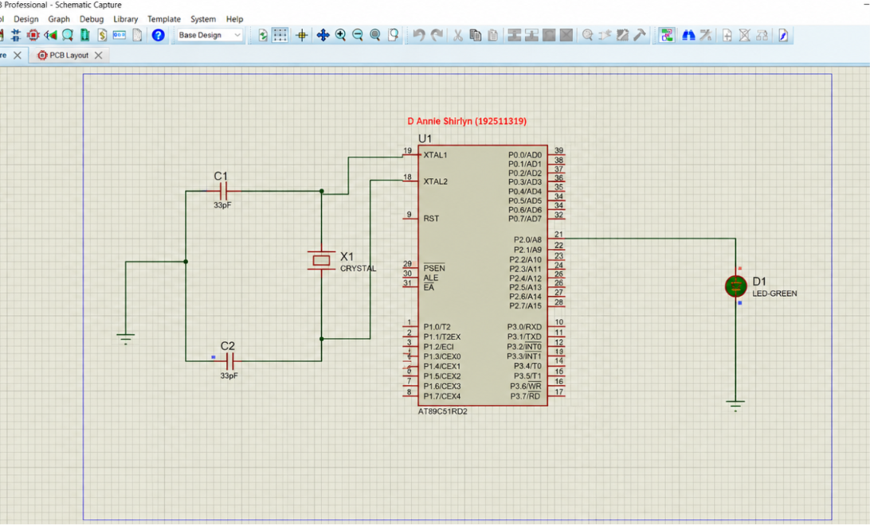

EXPERIMENT 2:
PROGRAM:
ORG 0000H
UP: SETB P2.0
ACALL DELAY
CLR P2.0
ACALL DELAY
SJMP UP
DELAY: MOV R4,#35
H1:MOV R3,#255
H2:DJNZ R3,H2
DJNZ R4,H1
RET
END
OUTPUT:
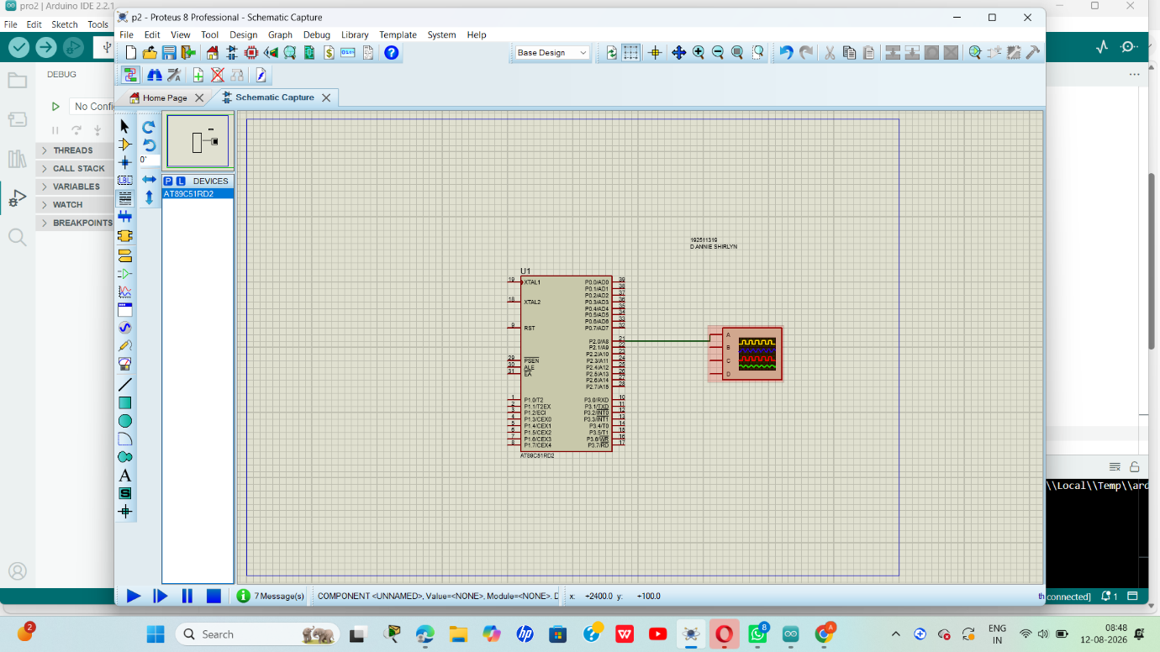
EXPERIMENT 3:
PROGRAM:
ORG 0000H
UP: MOV P2,#09H
ACALL DELAY
MOV P2,#0CH
ACALL DELAY
MOV P2,#06H
ACALL DELAY
MOV P2,#03H
ACALL DELAY
SJMP UP
DELAY:MOV R4,#18
H1:MOV R3,#255
H2:DJNZ R3,H2
DJNZ R4,H1
RET
END
OUTPUT:
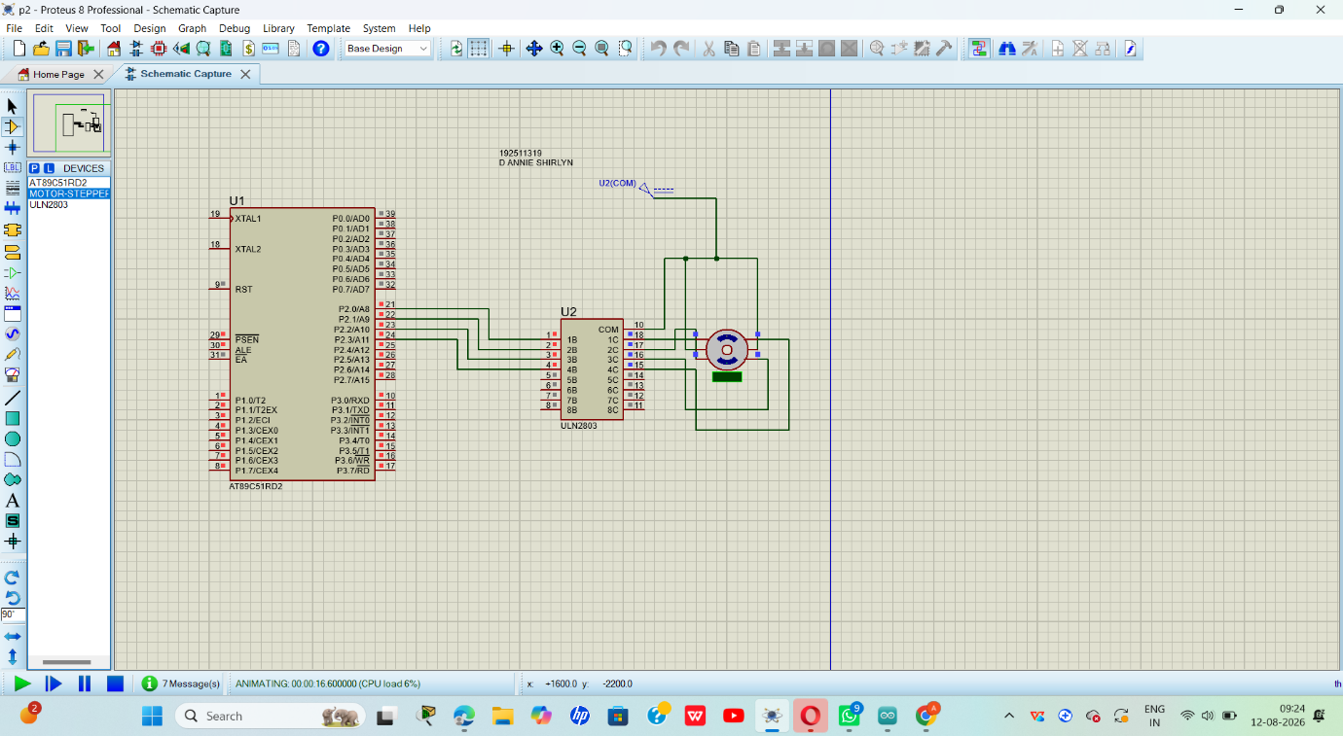
EXPERIMENT 4:
PROGRAM:
ORG 000H
UP:MOV P2,#0C0H
ACALL DELAY
MOV P2,#0F9H
ACALL DELAY
MOV P2,#0A4H
ACALL DELAY
MOV P2,#0B0H
ACALL DELAY
MOV P2,#99H
ACALL DELAY
MOV P2,#92H
ACALL DELAY
MOV P2,#82H
ACALL DELAY
MOV P2,#0F8H
ACALL DELAY
MOV P2, #80H
ACALL DELAY
MOV P2,#90H
ACALL DELAY
DELAY: MOV R5,#10
H1:MOV R4,#180
H2:MOV R3,#255
H3:DJNZ R3,H3
DJNZ R4,H2
DJNZ R5,H1
RET
END
OUTPUT:
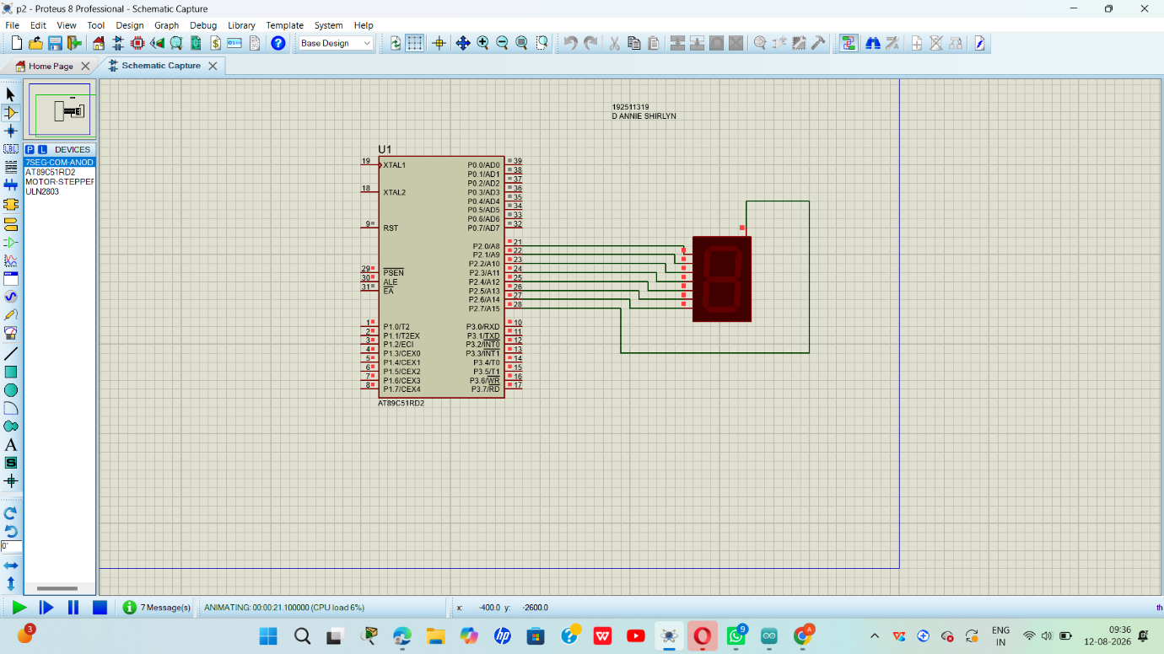

EXPERIMENT 5:
PROGRAM:
int x0,x1,x2,x3,x4,x5,x6,x7,x8,x9;
int delay_time=200;

void setup() {
//configure pin2 as an input and enable the internal pull-up resistor
pinMode(12, INPUT_PULLUP);
pinMode(1,OUTPUT);

pinMode(2,OUTPUT);
pinMode(3,OUTPUT);
pinMode(4,OUTPUT);
pinMode(5,OUTPUT);
pinMode(6,OUTPUT);
pinMode(7,OUTPUT);

}
void loop() {
//read the pushbutton value into a variable
int sensorVal = digitalRead(12);

if (sensorVal == LOW) {
x0=true;
}
while(x0){
zero();
sensorVal = digitalRead(12);
if (sensorVal == LOW) {
x1=true;
x0=false;
}
}
while(x1){
one();
sensorVal = digitalRead(12);
if (sensorVal == LOW) {
x2=true;
x1=false;
}

}
while(x2){
two();
sensorVal = digitalRead(12);
if (sensorVal == LOW) {
x3=true;
x2=false;
}
}
while(x3){
three();
sensorVal = digitalRead(12);
if (sensorVal == LOW) {
x4=true;
x3=false;
}
}
while(x4){
four();
sensorVal = digitalRead(12);
if (sensorVal == LOW) {
x5=true;
x4=false;
}
}
while(x5){
five();
sensorVal = digitalRead(12);
if (sensorVal == LOW) {
x6=true;

x5=false;
}
}
while(x6){
six();
sensorVal = digitalRead(12);
if (sensorVal == LOW) {
x7=true;
x6=false;
}
}
while(x7){
seven();
sensorVal = digitalRead(12);
if (sensorVal == LOW) {
x8=true;
x7=false;
}
}
while(x8){
eight();
sensorVal = digitalRead(12);
if (sensorVal == LOW) {
x9=true;
x8=false;
}
}
while(x9){
nine();
sensorVal = digitalRead(12);

if (sensorVal == LOW) {
x0=true;
x9=false;
}
}

}

void zero()
{
for(int i=1;i<7;i++)
{
digitalWrite(i,HIGH);
digitalWrite(7,LOW);
}
delay(delay_time);
}

void one()
{
digitalWrite(1,LOW);
digitalWrite(2,HIGH);
digitalWrite(3,HIGH);
digitalWrite(4,LOW);
digitalWrite(5,LOW);
digitalWrite(6,LOW);
digitalWrite(7,LOW);
delay(delay_time);
}

void two()
{
digitalWrite(1,HIGH);
digitalWrite(2,HIGH);
digitalWrite(3,LOW);
digitalWrite(4,HIGH);
digitalWrite(5,HIGH);
digitalWrite(6,LOW);
digitalWrite(7,HIGH);
delay(delay_time);
}

void three()
{
digitalWrite(1,HIGH);
digitalWrite(2,HIGH);
digitalWrite(3,HIGH);
digitalWrite(4,HIGH);
digitalWrite(5,LOW);
digitalWrite(6,LOW);
digitalWrite(7,HIGH);
delay(delay_time);
}

void four()
{
digitalWrite(1,LOW);
digitalWrite(2,HIGH);
digitalWrite(3,HIGH);
digitalWrite(4,LOW);

digitalWrite(5,LOW);
digitalWrite(6,HIGH);
digitalWrite(7,HIGH);
delay(delay_time);
}

void five()
{
digitalWrite(1,HIGH);
digitalWrite(2,LOW);
digitalWrite(3,HIGH);
digitalWrite(4,HIGH);
digitalWrite(5,LOW);
digitalWrite(6,HIGH);
digitalWrite(7,HIGH);
delay(delay_time);
}

void six()
{
digitalWrite(1,HIGH);
digitalWrite(2,LOW);
digitalWrite(3,HIGH);
digitalWrite(4,HIGH);
digitalWrite(5,HIGH);
digitalWrite(6,HIGH);
digitalWrite(7,HIGH);
delay(delay_time);
}

void seven()
{
digitalWrite(1,HIGH);
digitalWrite(2,HIGH);
digitalWrite(3,HIGH);
digitalWrite(4,LOW);
digitalWrite(5,LOW);
digitalWrite(6,LOW);
digitalWrite(7,LOW);
delay(delay_time);
}

void eight()
{
digitalWrite(1,HIGH);
digitalWrite(2,HIGH);
digitalWrite(3,HIGH);
digitalWrite(4,HIGH);
digitalWrite(5,HIGH);
digitalWrite(6,HIGH);
digitalWrite(7,HIGH);
delay(delay_time);
}

void nine()
{
digitalWrite(1,HIGH);
digitalWrite(2,HIGH);
digitalWrite(3,HIGH);
digitalWrite(4,HIGH);

digitalWrite(5,LOW);
digitalWrite(6,HIGH);
digitalWrite(7,HIGH);
delay(delay_time);
}
OUTPUT:
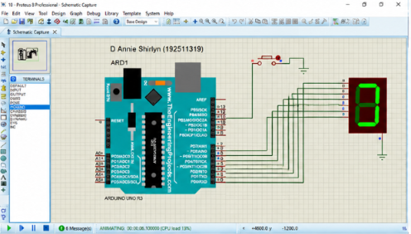

EXPERIMENT 6:
PROGRAM:
Arduino to 16x2 LCD Display using Proteus
#include <LiquidCrystal.h>
LiquidCrystal lcd (7, 8, 9, 10, 11, 12);
// your PWM numbers may be different

void setup() {

lcd.begin(16, 2);

lcd.print("put your message here");

}

void loop () {

for (int i=0; 1<13; i++)
}

lcd.scrollDisplayLeft();
delay(700);

}
}
OUTPUT:

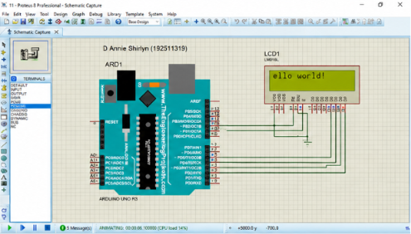
EXPERIMENT 7:
PROGRAM:
void setup()
{
Serial.begin(9600); // send and receive at 9600 baud
}

int number = 0;

void loop()
{
Serial.print("Number is ");
Serial.println(number); // print the number
delay(500); // delay half second between numbers
number++; // to the next number
}
OUTPUT:
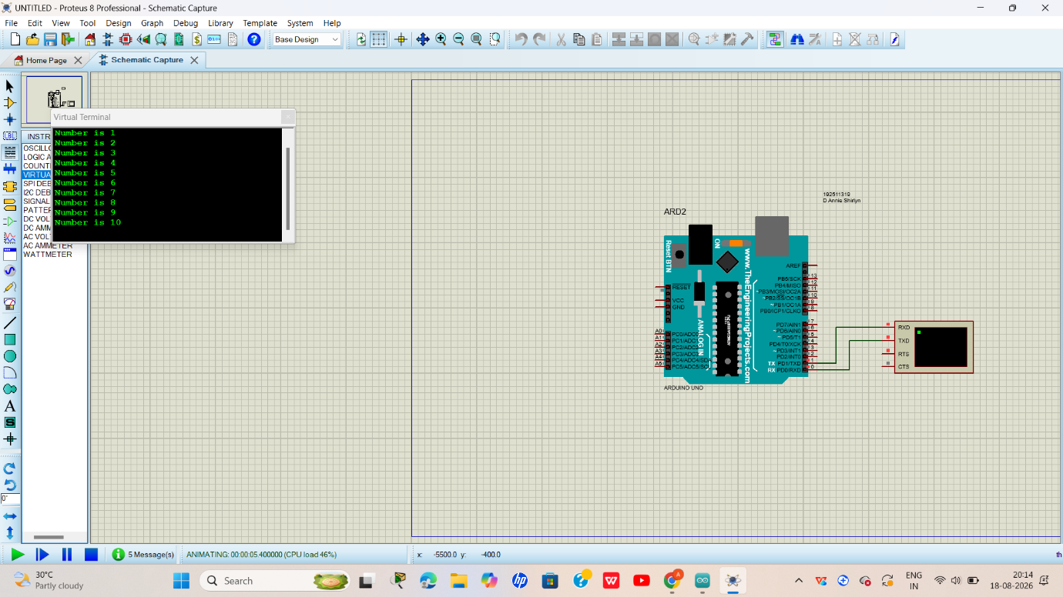
EXPERIMENT 8:
PROGRAM:
#define GreenLed 13
#define Sensor A0

void setup(){
pinMode(13,OUTPUT);
pinMode(12,OUTPUT);
pinMode(A0,INPUT);
Serial.begin(9600);

}
void loop() {
int value = analogRead(A0);
Serial.print("Analogic Value coming from the sensor : ");
Serial.println(value);
delay(100);
if(value>600){
digitalWrite(13,HIGH);
}
else{
digitalWrite(13,LOW);
}
delay(20);
}
Code for MQ6 sensor:
int mq6Pin = A0; // MQ-5 analog pin connected to A0

void setup() {
Serial.begin(9600);
}

void loop() {
int sensorValue = analogRead(mq5Pin);
Serial.print("MQ5 Sensor Value: ");
Serial.println(sensorValue);
delay(1000); // 1-second delay
}
OUTPUT:
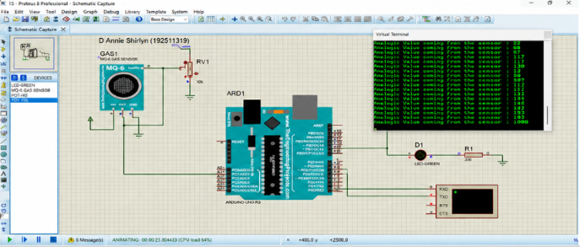

EXPERIMENT 9:
PROGRAM:
// Program Sketch
int trig = 10;
int echo = 9;
long duration;
int cm;
void setup() {
// put your setup code here, to run once:
pinMode(trig, OUTPUT);
pinMode(echo,INPUT);

Serial.begin(9600);
}
void loop() { // Sketch to calculate ultrasonic distance
digitalWrite(trig, LOW);
delayMicroseconds(10);
digitalWrite(trig, HIGH);
delayMicroseconds(10);
digitalWrite(trig, LOW);
delayMicroseconds(10);
duration = pulseIn(echo, HIGH);
cm = (duration/2) * 0.034;
// Print Value on Serial Monitor
Serial.print(" Distance = ");
Serial.print(cm);
Serial.println(" cm");
}
OUTPUT:
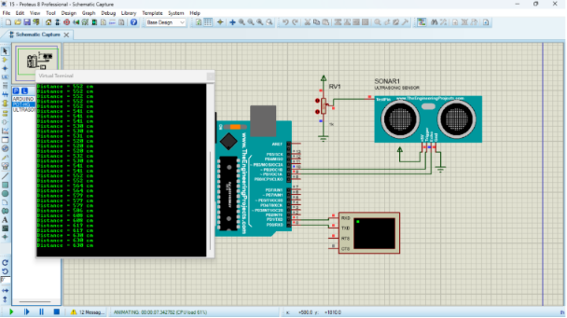
EXPERIMENT 10:
PROGRAM:
int Status = 13; // Digital pin D6
int sensor = 12; // Digital pin D7
void setup() {
Serial.begin(9600);
pinMode(sensor, INPUT); // declare sensor as input
pinMode(Status, OUTPUT); // declare LED as output
}

void loop() {
long state = digitalRead(sensor);
Serial.println(state);
if(state == HIGH) {
digitalWrite (Status, HIGH);
Serial.println("Motion detected!");
delay(1000);
}
else {
digitalWrite (Status, LOW);
Serial.println("Motion absent!");
delay(1000);
}
}
OUTPUT:
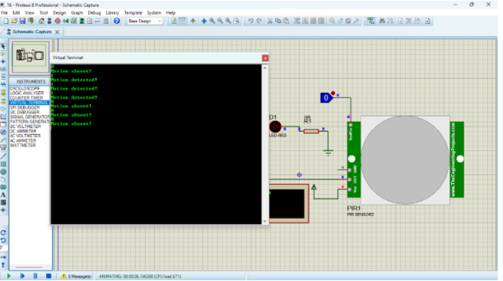
EXPERIMENT 11:
PROGRAM:
#include <reg51.h>
sbit LED1 = P1^0;
sbit LED2 = P1^1;
void delay()
{
unsigned int i,j;
for(i=0;i<200;i++)
for(j=0;j<1000;j++);
}
void main()
{
while(1)
{
LED1 = 1;
LED2 = 0;
delay();
LED1 = 0;
LED2 = 1;
delay();
}
}
OUTPUT:
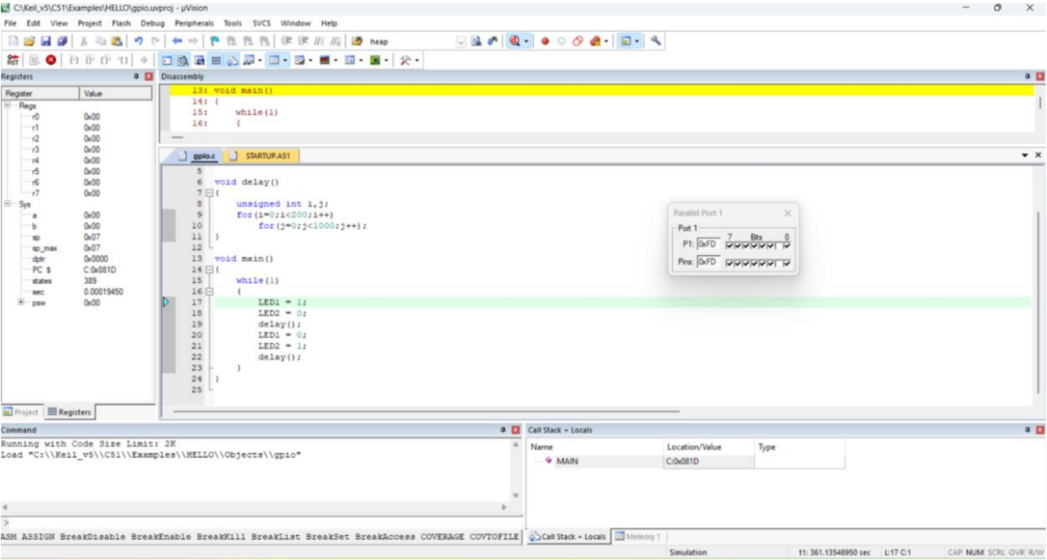
EXPERIMENT 12:
PROGRAM:
#include <reg51.h> void main()
{
while (1)
{
unsigned int num1, num2; unsigned long int product; num1 = 0x2222;
num2 = 0xBBBB;
product = (unsigned long int)num1 * num2; P0= product &0xff;
P1= (product & 0xff00)>>8;
P2 =(product & 0xff0000)>>16; P3 =(product & 0xff000000)>>24;
}
}
OUTPUT:
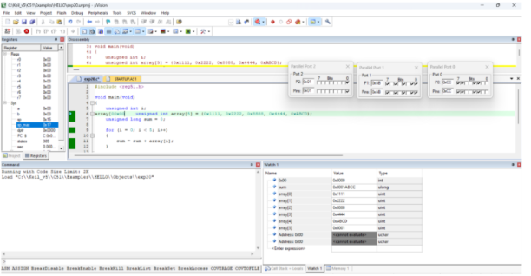
EXPERIMENT 13:
PROGRAM:
#include <reg51.h>

void main(void)
{
unsigned int i;
array[00x00 unsigned int array[5] = {0x1111, 0x2222, 0x8888, 0x4444, 0xABCD};
unsigned long sum = 0;

for (i = 0; i < 5; i++)
{
sum = sum + array[i];
}

P0 = (unsigned char)(sum & 0xFF); // Lower 8 bits
P1 = (unsigned char)((sum >> 8) & 0xFF); // Next 8 bits
P2 = (unsigned char)((sum >> 16) & 0xFF); // Upper 8 bits

while(1); // keep output stable
}

OUTPUT:
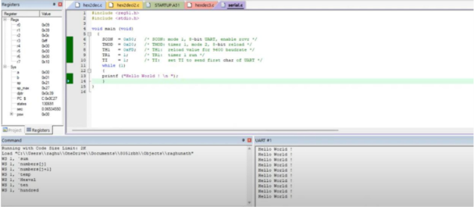
EXPERIMENT 14:
PROGRAM:
#include <reg51.h> #include <stdio.h>
void main (void){
SCON = 0x50; /* SCON: mode 1, 8-bit UART, enable rcvr */ TMOD = 0x20;
/* TMOD: timer 1, mode 2, 8-bit reload */ TH1 = 0xFD; /* TH1: reload

value for 9600 baudrate */
TR1 = 1; /* TR1: timer 1 run */
TI = 1; /* TI: set TI to send first char of UART */ while (1)
{
printf ("Hello World ! \n ");
}
}
OUTPUT:
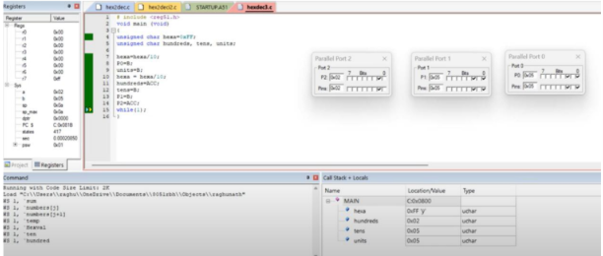
EXPERIMENT 15:
PROGRAM:
#include <reg51.h>
void main(void)
{
unsigned char hexa = 0x08;
unsigned char hundreds, tens, units;

ACC = hexa;
B = 10;
ACC = ACC / B;
units = B;

B = 10;
ACC = ACC / B;
tens = B;
hundreds = ACC;

P0 = units;
P1 = tens;
P2 = hundreds;

while(1);
}

OUTPUT:
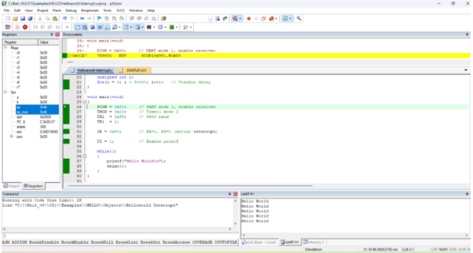
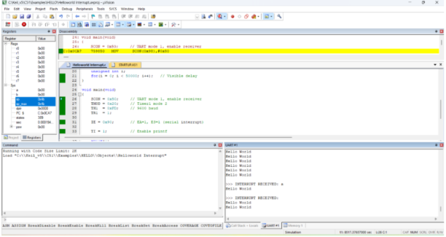
EXPERIMENT :16
PROGRAM:
#include <reg51.h>
#include <stdio.h>

void serial_ISR(void) interrupt 4
{
char ch;
if (RI)
{

RI = 0; // Clear receive interrupt flag
ch = SBUF; // Read received character

printf("\n>>> INTERRUPT RECEIVED: ");
printf("%c\n", ch);
}
}

void delay(void)
{
unsigned int i;
for(i = 0; i < 50000; i++); // Delay for visibility
}

void main(void)
{
SCON = 0x50; // UART mode 1, 8-bit, REN enabled
TMOD = 0x20; // Timer1 mode 2 (auto-reload)
TH1 = 0xFD; // Baud rate 9600
TR1 = 1; // Start Timer1

IE = 0x90; // EA = 1, ES = 1 (enable serial interrupt)

TI = 1; // Enable printf

while(1)
{
printf("Hello World\n");
delay();
}
}

OUTPUT:
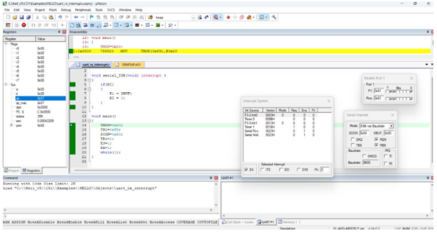
EXPERIMENT 17:
PROGRAM:
#include <reg51.h>
void serial_ISR(void) interrupt 4
{
if(RI)
{
P1 = SBUF;
RI = 0;
}
}
void main()
{
TMOD=0x20;
TH1=0xFD;
SCON=0x50;
TR1=1;
ES=1;
EA=1;
while(1);
}

OUTPUT:
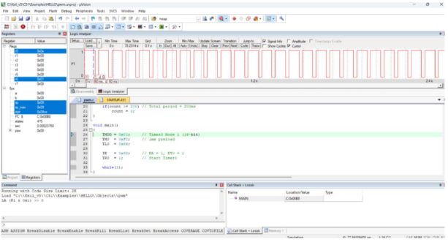
EXPERIMENT 18:
PROGRAM:
#include <reg51.h>

sbit PWM = P1^0;

unsigned char count = 0;
unsigned char duty = 100; // Change this value (0–200)

void timer0_ISR(void) interrupt 1
{
TH0 = 0xFC; // Reload for 1ms delay
TL0 = 0x66;

count++;

if(count < duty)
PWM = 1; // ON time
else
PWM = 0; // OFF time

if(count >= 200) // Total period = 200ms

count = 0;
}

void main()
{
TMOD = 0x01; // Timer0 Mode 1 (16-bit)
TH0 = 0xFC; // 1ms preload
TL0 = 0x66;

IE = 0x82; // EA = 1, ET0 = 1
TR0 = 1; // Start Timer0

while(1);
}
OUTPUT:

EXPERIMENT:19
PROGRAM:
#include "lpc214x.h"
void delay (unsigned int k);
void main(void)
{
IODIR0 = 0xFFFFFFFF; //Configure Port0 as output Port
PINSEL0 = 0; //Configure Port0 as General Purpose IO
while(1)
{
IOSET0 = 0x0000ff00; //Set P0.15-P0.8 to '1'
delay(1000); //1 sec Delay
IOCLR0 = 0x0000ff00; //Set P0.15-P0.8 to '0'
delay(1000); //1 Sec Delay
}
}
//Delay Program
//Input - delay value in milli seconds
void delay(unsigned int k)
{
unsigned int i,j;
for (j=0; j<k; j++)

for(i = 0; i<=800; i++);

}
OUTPUT:
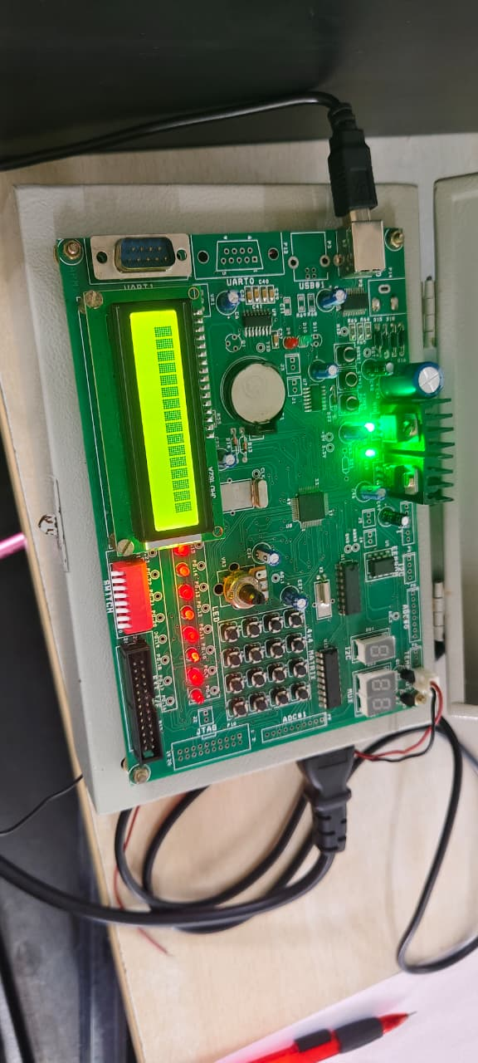
EXPERIMENT 20:
PROGRAM:
#include "lpc214x.h"
int main(void)
{
unsigned int sw_sts;
IODIR0 = 0x0000ff00; //Configure Port0
PINSEL0 = 0; //Configure Port0 as General Purose IO
while(1)
{
sw_sts = IOPIN0;
IOSET0 = 0x0000ff00; //Set P0.15-P0.8 to '1'
IOCLR0 = sw_sts >> 8; //Set P0.15-P0.8 to '0'
}
}
OUTPUT:
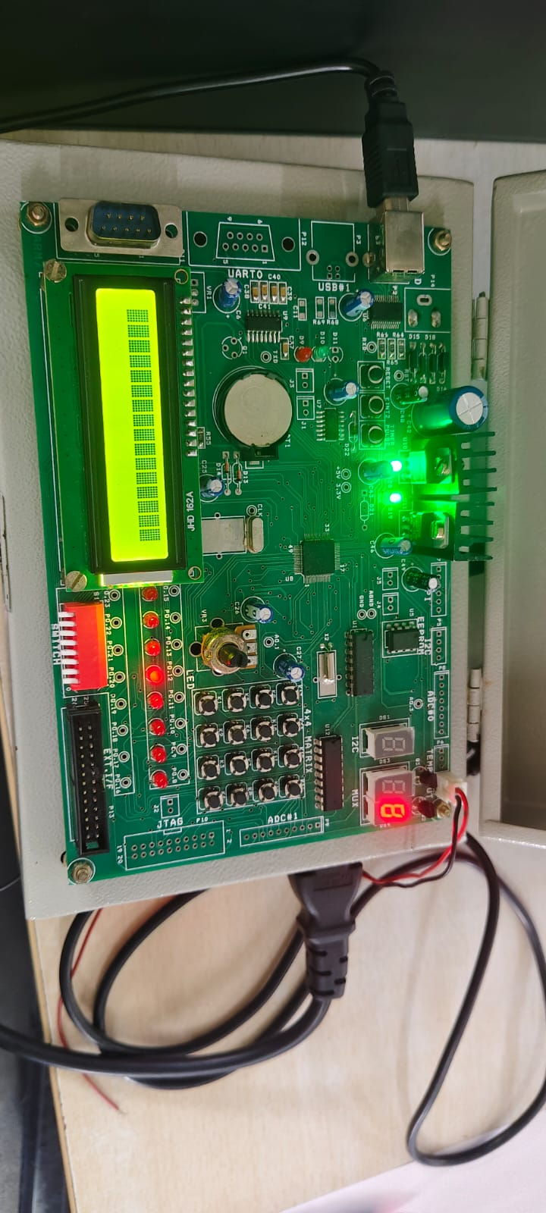
EXPERIMENT 21:
PROGRAM:
#include <LPC214X.H>
#define DS3 1<<13 // P0.13
#define DS4 1<<12 // P0.12
#define SEG_CODE 0xFF<<16 // Segment Data from P0.16 to P0.23
unsigned char const seg_dat[]={0x3F, 0x6, 0x5B, 0x4F, 0x66, 0x6D, 0x7D, 0x7, 0x7F,
0x67};

void delayms(int n)
{
int i,j;
for(i=0;i<n;i++)
{for(j=0;j<5035;j++) //5035 for 60Mhz ** 1007 for 12Mhz
{;}
}
}

int main (void)
{
unsigned char count;

PINSEL0 = 0; // Configure Port0 as General Purpose IO => P0.0 to P0.15
PINSEL1 = 0; // Configure Port0 as General Purpose IO => P0.16 to P0.31
IODIR0 = SEG_CODE | DS3 | DS4; //Configure Segment data & Select signal as output
IOSET0 = SEG_CODE | DS3 ; //Disable DS3 display
IOCLR0 = DS4; //Enable DS4 Display
count = 0; //Initialize Count

//Display Count value
IOCLR0 = SEG_CODE;
IOSET0 = seg_dat[count]<<16;

while(1)
{
delayms(1000); //1 sec delay
count++; //Increment count
if(count>9) count=0; //Limit 0-9

//Display Count value
IOCLR0 = SEG_CODE;
IOSET0 = seg_dat[count]<<16;

}
}
OUTPUT:

EXPERIMENT 22:
PROGRAM:
#include <lpc214x.h>
void UART0_Init(void)
{
PLL0CON = 0;
PLL0FEED=0xAA;
PLL0FEED=0x55;
VPBDIV = 1;
// Fpclk = 12.000.000 MHz
// DLM,DLH = Fpclk / (19200*16) = 39 = 0x27
PINSEL0 |= 0x5; // Select UART0 RXD/TXD
U0FCR = 0; // Disable FIFO's
U0LCR = 0x83; // 8N1, enable Divisor latch bit
U0DLL = 0x27; // baud rate fixed to 19200 @ PCLK = 12 Mhz
U0DLM = 0;
U0LCR = 3; // Disable Divisor latch bit
}
/*------------------------------------------------------------------*/
/* Function to send one char. to Serial Port */
void sout(unsigned char dat1)
{

while(!(U0LSR & 0x20));//Wait for Tx Buffer Empty
U0THR = dat1; //Send to UART1
}
/*-------------------------------------------------------*/

int main (void)
{ int dat;
UART0_Init();
do
{
if(U0LSR & 1) /* Check for RDR (Receiver Data Ready)command */
{
dat = U0RBR;// Receive Data from Srial Port
sout(dat); // Send Data to Srial Port
}
}while(1);
}
OUTPUT:
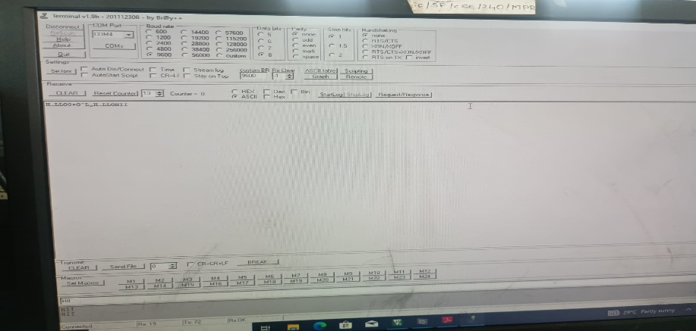
EXPERIMENT 23:
PROGRAM:
#include <LPC214X.H>
#define LEDS 0xFF<<8 //LED => P0.8 to P0.15
/////////////////////////////////////////
/*--- ADC Signal Declaration */
/////////////////////////////////////////
#define AD0_1 1<< 24
#define CLK_DIV 1<<8
#define PDN 1<<21
#define SOC 1<<24
#define BURST 1<<16
#define DONE 1<<31

/*-----------------------------------------------------------*/
//Delay Program
//Input - delay value in milli seconds
void delay(unsigned int k)
{
unsigned int i,j;
for (j=0; j<k; j++)
for(i = 0; i<=800; i++);

}
/*-----------------------------------------------------------*/
void adc_init()
{
unsigned long int ADC_CH;

ADC_CH = 0 | 1 << 1; //Channel AD0.1
AD0CR = SOC | PDN | CLK_DIV | ADC_CH | BURST ;
}
/*-----------------------------------------------------------*/
unsigned int adc_read( unsigned char channel)
{
unsigned int aval;
unsigned long int val;

if (channel == 1) val = AD0DR1;
else if (channel == 2) val = AD0DR2;
else if (channel == 3) val = AD0DR3;

val = val >> 6;
val = val & 0x3FF;
aval = val;
return (aval);
}
/*-----------------------------------------------------------*/
//////////////////////////
/*----Main Program------*/
//////////////////////////
int main(void)
{

unsigned int tp1;

IODIR0 = LEDS; //Configure Port0 as output Port
PINSEL0 = 0; //Configure Port0 as General Purpose IO
PINSEL1 = 0 | AD0_1; // Enable AD0.1

adc_init(); //Initialise on-chip ADC

do
{ tp1 = adc_read(1); // Channel AD0 0.1

tp1 = tp1 >> 2; // ADC 10 bit But LED 8bit, Truncate lsb 2 bits

IOSET0 = LEDS; //Switch OFF all LEDS
IOCLR0 = tp1 << 8; //Set VAlue
delay(1000);
}while(1);
}
OUTPUT:
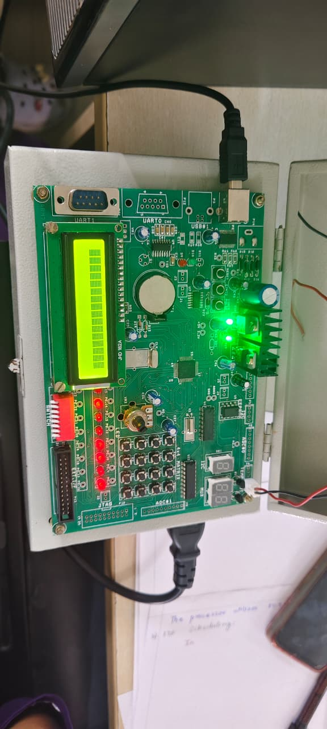
EXPERIMENT 24:
PROGRAM:
#include <systemc.h>

SC_MODULE(ClockExample) {
sc_in<bool> clk;

void process() {
while (true) {
wait();
std::cout << "Time: " << sc_time_stamp()
<< " - Clock Triggered" << std::endl;
}
}

SC_CTOR(ClockExample) {
SC_THREAD(process);
sensitive << clk.pos();

}
};

int sc_main(int argc, char* argv[]) {

sc_clock clock("clock", 1, SC_NS);

ClockExample module("module");
module.clk(clock);

sc_start(5, SC_NS);

return 0;
}
OUTPUT:
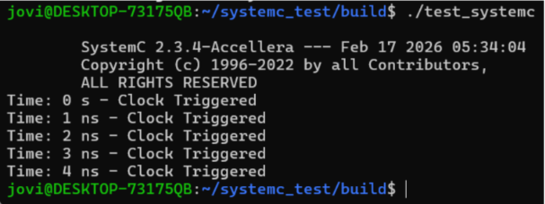
EXPERIMENT25:
PROGRAM:
#include <systemc.h>

// Producer Module
SC_MODULE(Producer) {
sc_fifo_out<int> out;

void produce() {
for (int i = 1; i <= 5; i++) {
cout << "Produced: " << i << endl;
out.write(i);
wait(1, SC_SEC);

}
}

SC_CTOR(Producer) {
SC_THREAD(produce);
}
};

// Consumer Module
SC_MODULE(Consumer) {
sc_fifo_in<int> in;

void consume() {
int value;
while (true) {
in.read(value);
cout << "Consumed: " << value << endl;
wait(1, SC_SEC);
}
}

SC_CTOR(Consumer) {
SC_THREAD(consume);
}
};

int sc_main(int argc, char* argv[]) {
sc_fifo<int> fifo(5);

Producer producer("Producer");
Consumer consumer("Consumer");

producer.out(fifo);
consumer.in(fifo);

sc_start(10, SC_SEC);

return 0;
}
OUTPUT:
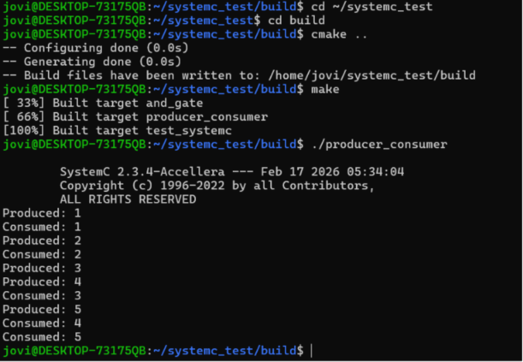

EXPERIMENT 26:
PROGRAM:
#include <systemc>
#include <tlm>
#include <tlm_utils/simple_initiator_socket.h>
#include <tlm_utils/simple_target_socket.h>

using namespace sc_core;
using namespace tlm;
using namespace std;

// Target
struct Target : sc_module {
tlm_utils::simple_target_socket<Target> socket;

SC_CTOR(Target) : socket("socket") {
socket.register_b_transport(this, &Target::b_transport);
}

void b_transport(tlm_generic_payload& trans, sc_time& delay) {
int* data = (int*) trans.get_data_ptr();
cout << "Target received: " << *data << endl;

delay += sc_time(10, SC_NS);
}
};

// Initiator
struct Initiator : sc_module {
tlm_utils::simple_initiator_socket<Initiator> socket;

SC_CTOR(Initiator) : socket("socket") {
SC_THREAD(thread_process);
}

void thread_process() {
tlm_generic_payload trans;
sc_time delay = SC_ZERO_TIME;

int data = 555;

trans.set_data_ptr(reinterpret_cast<unsigned char*>(&data));
trans.set_data_length(sizeof(data));

cout << "Initiator sending: " << data << endl;
socket->b_transport(trans, delay);

wait(delay);
}
};

int sc_main(int argc, char* argv[]) {

Initiator initiator("initiator");
Target target("target");

initiator.socket.bind(target.socket);

sc_start();

return 0;
}
OUTPUT:
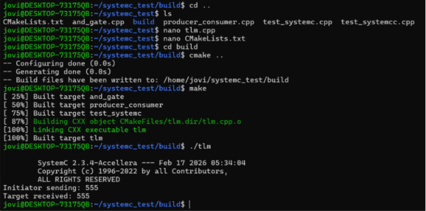
EXPERIMENT 27:
PROGRAM:
#include <systemc.h>

SC_MODULE(binary_semaphore) {

int sem;
sc_event ev;

void task1() {
while(true) {
wait(1, SC_SEC);

if(sem == 1) {

sem = 0;
cout << "Task1 Entered Critical Section at " << sc_time_stamp() << endl;
wait(2, SC_SEC);
sem = 1;
ev.notify();
}
else {
wait(ev);
}
}
}

void task2() {
while(true) {
wait(2, SC_SEC);

if(sem == 1) {
sem = 0;
cout << "Task2 Entered Critical Section at " << sc_time_stamp() << endl;
wait(1, SC_SEC);
sem = 1;
ev.notify();
}
else {
wait(ev);
}
}
}

SC_CTOR(binary_semaphore) {
sem = 1;
SC_THREAD(task1);
SC_THREAD(task2);
}

};

int sc_main(int argc, char* argv[]) {
binary_semaphore obj("Binary_Semaphore");
sc_start(10, SC_SEC);
return 0;
}

OUTPUT:
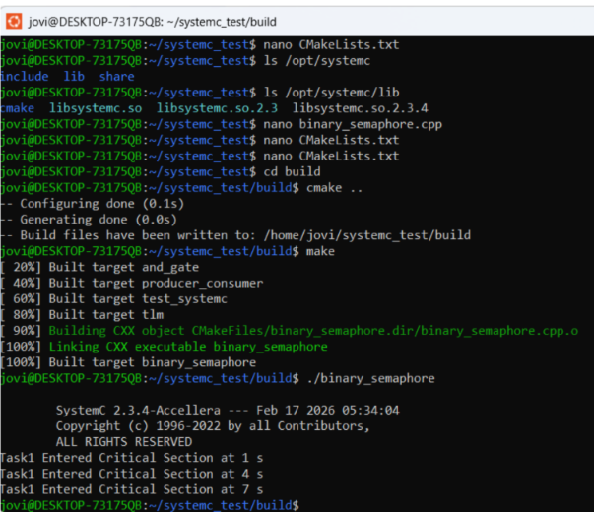
EXPERIMENT 28:
PROGRAM:
#include <systemc.h>

SC_MODULE(counting_semaphore) {

int sem;

void task() {
while(true) {
wait(1, SC_SEC);

if(sem > 0) {
sem--;
cout << "Task Accessing Resource at "
<< sc_time_stamp()
<< " Remaining: " << sem << endl;

wait(2, SC_SEC);
sem++;
}

}
}

SC_CTOR(counting_semaphore) {
sem = 2;
SC_THREAD(task);
SC_THREAD(task);
SC_THREAD(task);
}
};

int sc_main(int argc, char* argv[]) {
counting_semaphore obj("Counting");
sc_start(10, SC_SEC);
return 0;
}

OUTPUT:
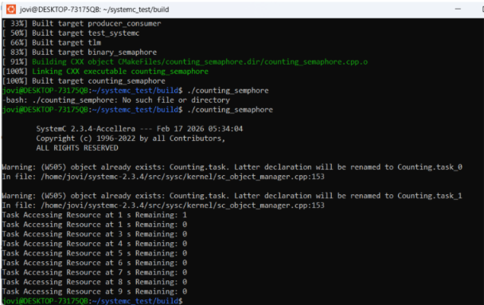
EXPERIMENT 29:
PROGRAM:
#include <systemc.h>

SC_MODULE(priority_interrupt) {

sc_event low_int, high_int;

void low_ISR() {
while(true) {
wait(low_int);
cout << "Low Priority Interrupt at "
<< sc_time_stamp() << endl;
wait(3, SC_SEC);
}
}

void high_ISR() {
while(true) {
wait(high_int);
cout << "High Priority Interrupt at "

<< sc_time_stamp() << endl;
wait(1, SC_SEC);
}
}

void generator() {
wait(1, SC_SEC);
low_int.notify();

wait(1, SC_SEC);
high_int.notify();
}

SC_CTOR(priority_interrupt) {
SC_THREAD(low_ISR);
SC_THREAD(high_ISR);
SC_THREAD(generator);
}
};

int sc_main(int argc, char* argv[]) {
priority_interrupt obj("Priority_INT");
sc_start(10, SC_SEC);
return 0;
}

OUTPUT:
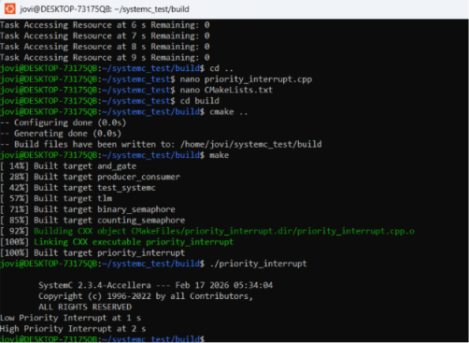
EXPERIMENT 30:
PROGRAM:
#include <systemc.h>
SC_MODULE(rtos_scheduler) {
void task1() {
while(true) {
cout << "Task1 Running at "
<< sc_time_stamp() << endl;
wait(1, SC_SEC);
}
}
void task2() {
while(true) {
cout << "Task2 Running at "
<< sc_time_stamp() << endl;
wait(1, SC_SEC);
}
}
SC_CTOR(rtos_scheduler) {
SC_THREAD(task1);
SC_THREAD(task2);
}
};

int sc_main(int argc, char* argv[]) {
rtos_scheduler obj("Scheduler");
sc_start(6, SC_SEC);
return 0;
}

OUTPUT:
